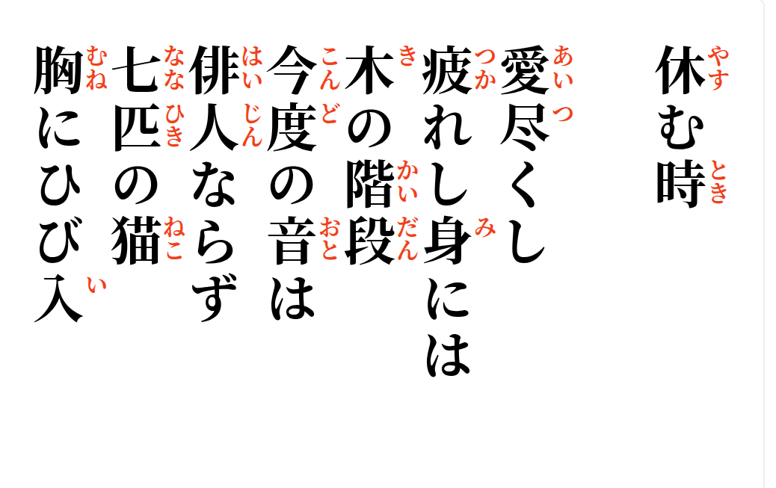

2026-09-08
Having given love,
the tired body meets
the hardwood stair—
this time the sound
is not the haijin.
Seven cats leap;
a crack enters the chest

